**Question 4 Example.**

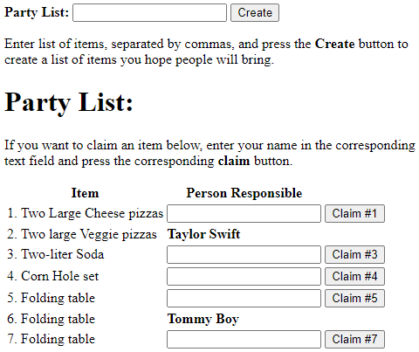You want to create an application that allows you to create a Party List for which people will claim different items. To claim an item, you type your name in a text field and press the corresponding **Claim #** button.

## Use Cases

As a reminder, here are the use cases:

* Create PartyList
* Show PartyList
* Claim Item

## API Design template

Based on the use cases, you need to define entry points using the following standard:

/resourceName

GET or POST

Payload-to-aws-if-present

200:

Payload-out-on-success

400:

Payload-out-on-failure

## Create PartyList

/create

POST

{ "items" : [  
 { "item" : "Two Large Cheese Pizzas" },  
 { "item" : "Folding Table" },  
 ...

] }

200:

PARTY-LIST

400:

{ "error" : "No items in list” }

## Show PartyList

/show

GET

200:

PARTY-LIST

400:

{ "error" : "No List" }

## Claim Item

/claim

POST  
 { "item" : "2. Two large Veggie pizzas", "name" : "Taylor Swift" }

200:

PARTY-LIST

400:

{ "error" : "No Such Item" }

{ "error" : "Item Already Claimed" }

## Payload Definitions

For convenience you can refer to specific payloads BY NAME within your API without having to copy them multiple times:

* PARTY-LIST  
    
  { "items": [

{ "item" : "1. Two Large Cheese pizzas" },

{ "item" : "2. Two large Veggie pizzas", "person" : "Taylor Swift"}

...

]  
}

* Others as you need…